4th March 2014

YOKOHAMA to Release “iceGUARD Stud iG55” for Passenger Cars in Northern Europe and Russia

Tokyo – The Yokohama Rubber Co., Ltd., announced today that it will introduce a new studded tyre for passenger vehicles, the “iceGUARD Stud iG55,” into the northern Europe and Russian markets ahead of the 2014 autumn/winter snowy season. The “iceGUARD Stud iG55” seeks to improve tyre performance on icy surfaces while improving stud retention. The tyre is available in sizes from 13inch to 20inch.

The tyre’s development was based on a complete revision of the tread pattern, stud shape, and tyre compound. The new tread pattern maximizes the tyre’s contact with the road surface and enhances the edging effect. The new pattern also features an aggressive design intended to increase the tyres’ snow and water discharge capability. The “iceGUARD Stud iG55” features a newly developed shape for the studs and stud holes, with the new design optimizing tread thickness around the studs and stud hole allocation. The tyre compound has been applied water absorbing technology with “iceGUARD” series studless tyres. The compound also incorporates our proprietary orange oil, which enhances gripping power. The application of these technologies has significantly boosted the tyres’ performance on ice and their ability to hold the studs.

The “iceGUARD” brand is YOKOHAMA´s global winter tyre brand. It is marketed in many countries in northern Europe, Russia, North America, and Asia.

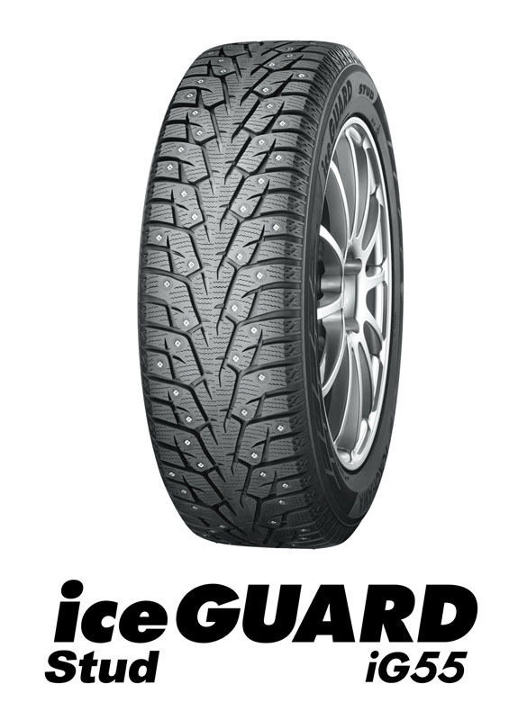

Release Reference Material

Technical approach－Tread pattern

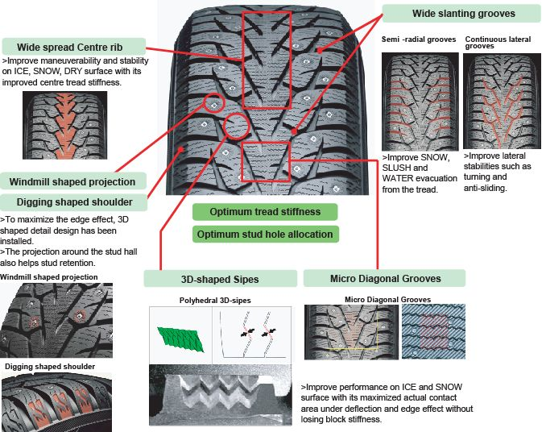

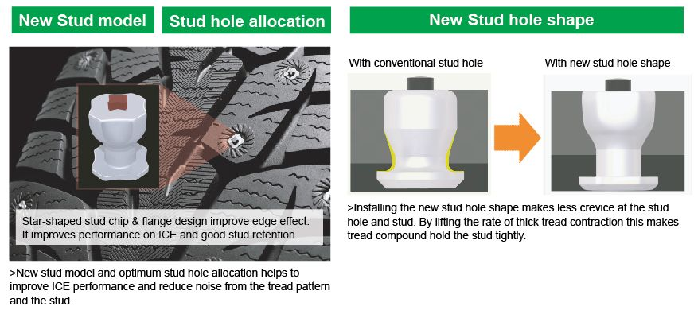
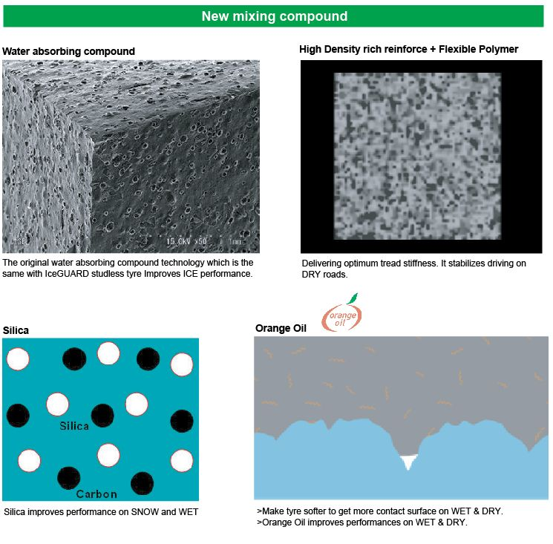
Technical approach－Stud

Technical approach－Compound

